Profitability Management in Accounting:

Bhanvi Gupta1( Student)

1 Narsee Monjee Institute of Management Studies Indore, Madhya Pradesh India

Corresponding author: Bhanvi Gupta(enter your email)

.

**ABSTRACT** Effective management information systems are a basic need of every administrator of a medical group practice. This general discussion of the subject of cost accounting enables the administrator to develop a standard cost system and its related detail cost sheets as a management information tool. Detail cost sheets can be useful in reviewing utilization of group resources, establishing a basis for fees, setting a uniform margin of expected profit, and as a guide in negotiation of contracts with third-party payers

**INDEX TERMS** Management, Administration, Cost Sheet.

**INTRODUCTION** A cost sheet is a statement which represents the various costs incurred at different stages of business operations, in a tabular format. It determines the total cost or expenditure made by the organization, along with the cost incurred on each unit of a product or service in a particular period. A cost sheet is a report which is accumulated all of the costs associated with a product or production job. A Cost Sheet depicts the following facts: 1. Total cost and cost per unit for a product. 2. The various elements of cost such as prime cost, factory cost, production cost, cost of goods sold, total cost, etc. 3. Percentage of every expenditure to the total cost. 4. Calculate and summarize the total cost of the product.

**METHODS**

### Facilitate team contribution

### Conduct market research

### Analyze market research

### Conduct market research

### Personalization

### Creative financing

### Analyze financial statement

### Eliminate nonessential processes

### Decrease spaces

### Create budgets

### Develop marketing and branding

### Increase dollars per transaction

### Reduce fixed overhead

### Focus on profitable customers

### Expand the market

### Facilitate team contribution One of the first strategies to help in increasing profitability is to meet with members of your team to establish common goals related to increasing profits. If team members are all aware of the goals of the organization, it can help them make decisions that assist in the completion of those goals and motivate them to increase their productivity. For example, you may hold a company-wide meeting where you discuss the goal of increasing profit margins by 10% within the next year.containers or delivery vehicles in real time to predict when items will arrive at their destinations. That data can then be mined to find the reasons for recurring delays. Any cloud-based inventory management software you choose, whether SaaS/cloud or on-premises, should integrate with your finance and accounting and order management systems and allow for granular tracking of inventory down to the SKU or barcode, whether items are in a warehouse or in transit.

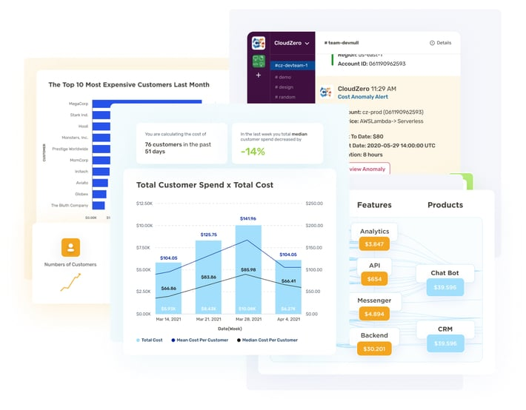

CONDUCT MARKET RESEARCH Conducting market research can help you identify target audiences and understand their motivations to purchase your product or services. Conducting this research can you determine the amount customers may spend on your products or services and help you market them better to consumers. For instance, if customers will spend $10 more on your products, you may increase the price to match that amount.

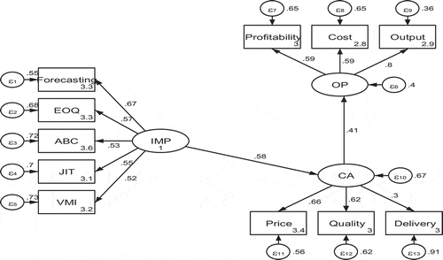

ANALYSE FINANCIAL STATEMENT Financial statements provide quantitative data on revenue and expenses that you can analyze to determine which processes you may adjust to increase profitability. Balance sheets, income statements and cash flow statements are all useful to analyze when seeking to increase profitability. For instance, you may determine expenses in one area are increasing as the business grows, allowing your team to focus on that area when making adjustments to improve profitability.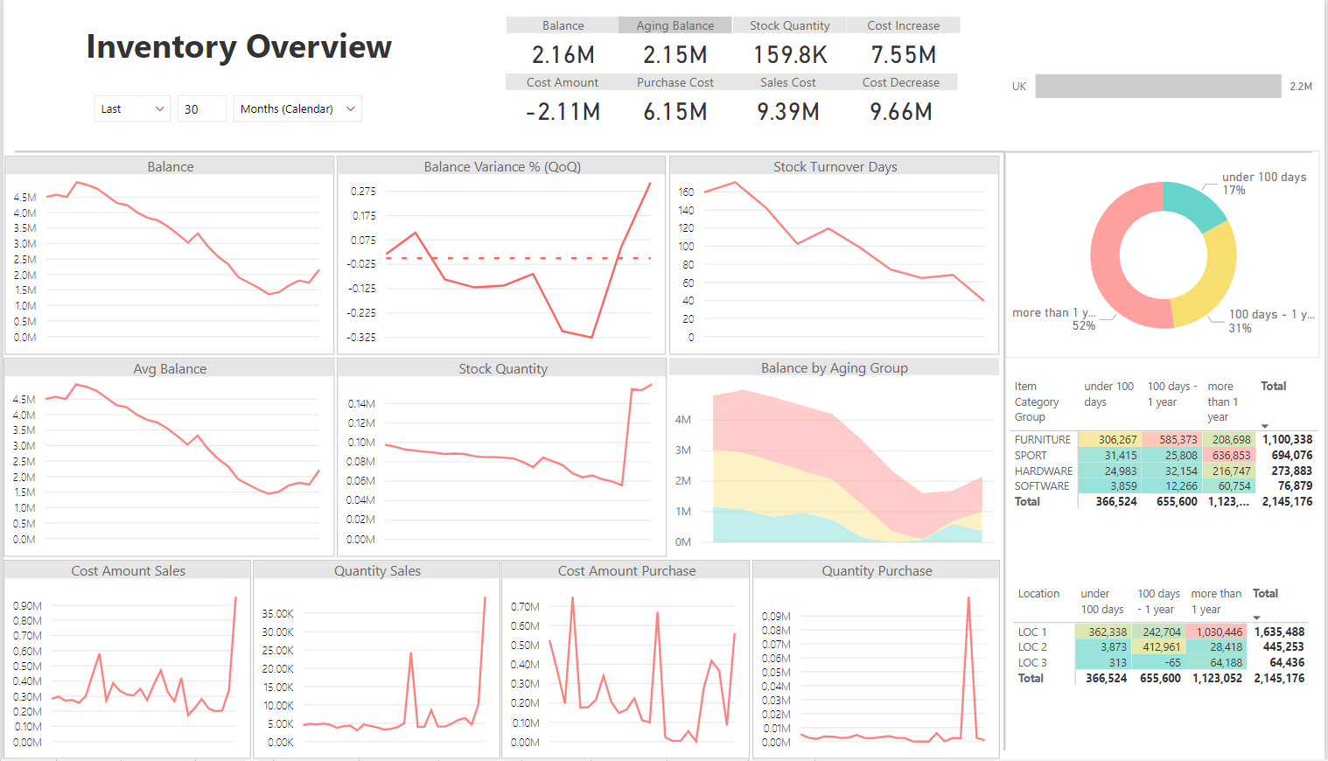

### Increase sales prices Predictive inventory management refers to the integration of predictive analytics to forecast the future risks that have the potential to disrupt inventory availability. The analytical process takes into consideration fluctuating demand, which is demand forecasting, historical data, and economic trends to proactively manage inventory. Thus, predictive inventory management includes demand forecasting, supply chain planning, and assortment planning.

## Supply Chain Planning Software and Optimizing Your Inventory Management Process

The extended capability supply chain planning software makes it possible to automate predictive inventory management among other benefits. These benefits include:

* Developing agile inventory strategies – The tools SCP provides enable you to understand the significant factors that affect the cost and service-levels of the inventory strategy you currently use. With this insight, effective cost-cutting measures can be put in place to optimize the inventory management process.
* Simulate and Predict Outcomes – SCP software provides you with an intelligent platform capable of answering what-if questions. With the data it captures or inputted in it, enterprises can introduce constraints or evaluate diverse scenarios to determine the business outcomes and its effect on available inventory or the supply chain. This makes supply chain planning software effective decision-making tools due to the insight and predictions they provide.
* Share Insights to Enhance Collaboration – SCP software doubles as a collaboration tool for organizations interested in ensuring every facet of their operations is in sync. This includes the various departments involved in production processes, third-party suppliers, and customers. Ensuring everyone has access to production-related timelines enables the involved parties to understand their responsibilities and the importance of meeting specified schedules.

INVENTORY FINANCING Inventory financing is a form of asset-based financing. Businesses turn to [lenders](https://www.investopedia.com/terms/l/lender.asp) so they can purchase the materials they need to manufacture products they intend to sell at a later date.1This kind of financing is common for small to mid-sized retailers and wholesalers, especially those with a large amount of available stock.2 That's because they typically lack the financial history and available [assets](https://www.investopedia.com/terms/a/asset.asp) to secure the institutional-sized financing options larger corporations are able to access, such as Walmart ([WMT](https://www.investopedia.com/markets/quote?tvwidgetsymbol=WMT)) and Target ([TGT](https://www.investopedia.com/markets/quote?tvwidgetsymbol=TGT)).Because they are generally [private companies](https://www.investopedia.com/terms/p/privatecompany.asp), they cannot raise money by issuing bonds or new rounds of stock. Companies may use all or part of their existing stock or the material they purchase as [collateral](https://www.investopedia.com/terms/c/collateral.asp) for a loan that is used for general [business expenses](https://www.investopedia.com/terms/b/businessexpenses.asp).As noted above, inventory financing allows businesses to purchase inventory to run their businesses. The reasons why they rely on this kind of financing include:

* Keeping cash flow steady through busy and slow seasons
* Updating product lines
* Increasing supplies of inventory
* Responding to (high) customer [demand](https://www.investopedia.com/terms/d/demand.asp)3

Types of Inventory Financing Lenders provide businesses with two different kinds of inventory financing. The option that the company chooses is dependent on its business operations. [Interest rates](https://www.investopedia.com/terms/i/interestrate.asp) and fees depend on the lender and the type of business.

* **Inventory loan:**Also referred to as term loans, this kind of financing is based on the total [value](https://www.investopedia.com/terms/v/value.asp) of the company's inventory. Just like a regular loan, the lender issues the company a specific amount of money. The company agrees to make fixed payments every month or to pay the loan off in full once the inventory is sold.
* **Line of credit:** This form of financing provides businesses with [revolving credit](https://www.investopedia.com/terms/r/revolvingcredit.asp), unlike a loan. It gives them regular access to credit as long as they make regular monthly payments to satisfy the terms and conditions of the contract

**AUTOMATION IN INVENTORY MANAGEMENT** An automated inventory management system is**a set of technologies, processes, and procedures for monitoring and servicing goods in warehouses**. It involves the use of systems and software to automate tasks such as tracking inventory levels, forecasting demand, ordering, and replenishing stock, and monitoring stock movements. The system can use barcoding, RFID, and other technologies to track inventory in real-time and automate various processes. Automated inventory systems are computerized methods of inventory tracking that work within EPOS to maintain, update, and monitor inventory. They use IoT and AI technologies to provide end-to-end inventory automation, support multi-location inventory management, demand-driven inventory planning, and inventory optimization based on advanced analytics. Automated inventory management systems optimize the inventory management process and let retailers and wholesalers manage their inventory in real-time.

Overall, an automated inventory tracking system can help you deal with inaccuracies and improve the production cycle. More specifically, you can benefit from:

* Redirecting your resources to high-value tasks that can make a greater impact on your business (with automation, you've got simple tasks covered).
* Reduced vulnerability and risk due to human error.
* The ability to scale quickly and add more products that your customers will love.
* Quick access to the data you need to deliver great customer service and make better business decisions.
* Less stress on your team, helping them work proactively to address potential issues.

### CONCLUSIONS This recent study aims at figuring out the best ways of inventory management and eliminating the drawbacks of traditional inventory management methods . The Research Paper successfully overviewed the new technology that made inventory management much easier efficient and accurate the use of modern technology, mathematics and statistics has made the accounting process more transparent and relevant.